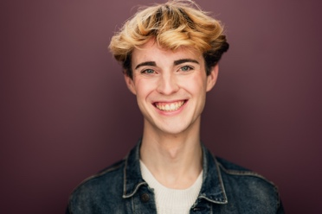
Samm Gibson
Point Park University COPA 2025 – BFA Acting
(904-540-6186) sammgibson1210@gmail.com
Hair: Blonde – Eyes: Blue – Height: 6’0” Voice Type: Baritenor – Vocal Range: G2-G4
THEATRE
12 Ophelia’s G Pittsburgh Playhouse: April Daras
The Trees Jared Pittsburgh Playhouse: Adil Mansoor
Newsies Finch / Crutchie U/S Pittsburgh Playhouse: Danny Herman
R&H Cinderella Ensemble Pittsburgh Playhouse: Tomé Cousins
Arcadia Septimus Hodge U/S Pittsburgh Playhouse: Phil Winters
*Waltz Choreographer
Kinky Boots Angel Player by the Sea : Joseph Kemper
SpongeBob SquarePants Plankton Players by the Sea: Joseph Kemper
She Kills Monsters Orcus/Ronnie Bridges Theater Co.: Madeline Bedford
Rent Ensemble/Mark U/S Dubow Theater: Joseph Kemper
Spring Awakening Ensemble/Hanschen U/S Player by the Sea: Bradley Akers
Lion and Mouse Story Devised Ensemble DuBow Theater: Bonnie Harrison
Guys and Dolls Emcee/Ensemble DuBow Theater : Joseph Kemper
Newsies Featured Dance Ensemble Florida State College : Michael Lipp
Curtains Ensemble DuBow Theater: Joseph Kemper
FILM
Lost In a Dream | Lead | DASOTA: Elizabeth Arcenuex
A Brothers Love | Featured Extra | DASOTA: Elizabeth Arcenuex
TRAINING - Point Park University 2025 – BFA Acting
Acting Kim Weild, Milia Ayache, Phil Winters, Meg Pryor, Chris Clavelli
Voice Devin Clevenger, Lisa Brovey-Kovach, Regina Torres
Dance Michelle Van Doeren, Robert McKee, , Rocker Verastique
Suzuki Christopher Staley
Alexander Technique Bonnie Harrison & Emily Sapa
Fitzmaurice John Gresh
Meisner Chris Clavelli
Étude’s Milia Ayache
SPECIAL SKILLS Dance: Choreography, Ballet, Tap, Jazz, Modern, Beginner Ballroom, Toe Touch and Cartwheels. Voice: RP, Cockney Gulf & Mountain Southern, New York and Irish (Trained with the International Phonetic Alphabet), Mickey Mouse Impression, Valid Passport,

